Practical 1
import java.applet.Applet;
import java.awt.*;
public class NewApplet extends Applet {
public void init() {
// TODO start asynchronous download of heavy resources
List l = new List(10,true);
l.add("Mumbai");
l.add("pune");
l.add("Nashik");
l.add("Nagpur");
l.add("Sangli");
l.add("Kolhapur");
l.add("Mumbai");
l.add("Mumbai");
l.add("Mumbai");
l.add("Mumbai");
add(l);
}}
Output:-
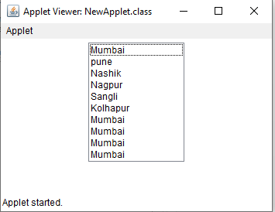

Practical no 2:-
import java.applet.Applet;
import java.awt.*;
public class choice extends Applet {
public void init()
Choice l = new Choice();
l.add("lokmat");
l.add("hindu ");
l.add("times of india");
l.add("pudhari");
l.add("Maharashtra times");
add(l);
}}
Output:-
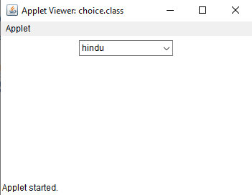

Practical no 3
1. Write java program to demonstrate Grid of 5* 5. using gridlayout
import java.applet.Applet;
import java.awt.GridLayout;
import java.awt.Button;
import java.awt.*;

public class GridApplet extends Applet {
public void init() {
setLayout(new GridLayout(5, 5));

for (int i = 0; i < 25; i++) {
Button button = new Button("Button " + (i + 1));
add(button);
}
}
}
Output:
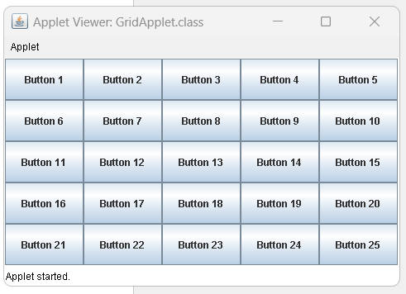
2. Write a program to display The Number on Buttons from 0 to 9.
import java.applet.Applet;
import java.awt.Button;
import java.awt.GridLayout;
public class NumberButtonsApplet extends Applet {
public void init() {
setLayout(new GridLayout(4, 3));
for (int i = 0; i <= 9; i++) {
Button button = new Button(String.valueOf(i)); // Create a button with the number as its label
add(button); // Add the button to the applet
}
}
}
Output:
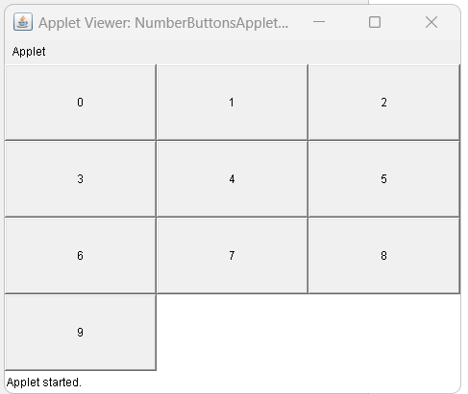

3. Write the java program to demonstrate the Grid 4 x 4 which displays numbers from 0 to 9
and all arithmetic operators to Design the Calculator.
using gridlayout
import java.applet.Applet;
import java.awt.Button;
import java.awt.GridLayout;
public class CalculatorApplet extends Applet {
public void init() {
setLayout(new GridLayout(4, 4));
for (int i = 0; i <= 9; i++) {
Button button = new Button(String.valueOf(i));
add(button);
} Button addButton = new Button("+");
add(addButton);
Button subtractButton = new Button("-");
add(subtractButton);
Button multiplyButton = new Button("*");
add(multiplyButton);
Button divideButton = new Button("/");
add(divideButton);
}
}
Output:
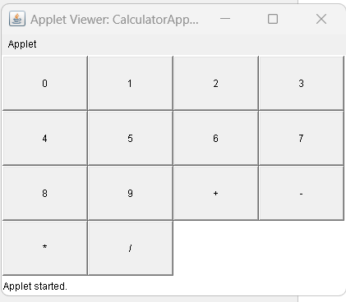

Exercise
1.
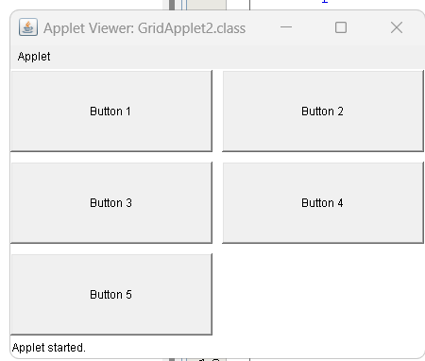

import java.applet.Applet;
import java.awt.Button;
import java.awt.GridLayout;

public class GridApplet2 extends Applet {
public void init() {
setLayout(new GridLayout(3, 2, 10, 10)); // Set the layout to GridLayout with 3 rows, 2 columns, and 10 pixels of horizontal and vertical spacing

// Create buttons from 0 to 5

Button button1 = new Button("Button 1");
Button button2 = new Button("Button 2");
Button button3 = new Button("Button 3");
Button button4 = new Button("Button 4");
Button button5 = new Button("Button 5");

// Add buttons to the applet

add(button1);
add(button2);
add(button3);
add(button4);
add(button5);
}
}

2.
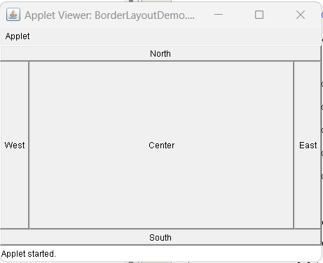
import java.applet.Applet;
import java.awt.BorderLayout;
import java.awt.Button;
public class BorderLayoutDemo extends Applet {
public void init() {
setLayout(new BorderLayout());
Button eastButton = new Button("East");
Button westButton = new Button("West");
Button northButton = new Button("North");
Button southButton = new Button("South");
Button centerButton = new Button("Center");

add(eastButton, BorderLayout.EAST);
add(westButton, BorderLayout.WEST);
add(northButton, BorderLayout.NORTH);
add(southButton, BorderLayout.SOUTH);
add(centerButton, BorderLayout.CENTER);
}

Practical 5
write a program using awt to create a meanu bar where bar contains items such as file,edit view and create a sub menu under the file meanu:new and open
import java.awt.*;

public class MenuBarExample {
public static void main(String[] args) {
Frame frame = new Frame("Menu Bar Example");
MenuBar menuBar = new MenuBar();
Menu fileMenu = new Menu("File");
MenuItem i1,i2,i3;
i1=new MenuItem("New");
fileMenu.add(i1);
i2=new MenuItem("Open");
fileMenu.add(i2);
i3=new MenuItem("Edit");
fileMenu.add(i3);
Menu editMenu = new Menu("Edit");
MenuItem i4,i5,i6;
i4=new MenuItem("Cut");
editMenu.add(i4);
i5=new MenuItem("Copy");
editMenu.add(i5);
i6=new MenuItem("Paste");
editMenu.add(i6);

Menu viewMenu = new Menu("View");
menuBar.add(fileMenu);
menuBar.add(editMenu);
menuBar.add(viewMenu);
frame.setMenuBar(menuBar);
frame.setSize(400, 300);
frame.setVisible(true);
}
}

Output:
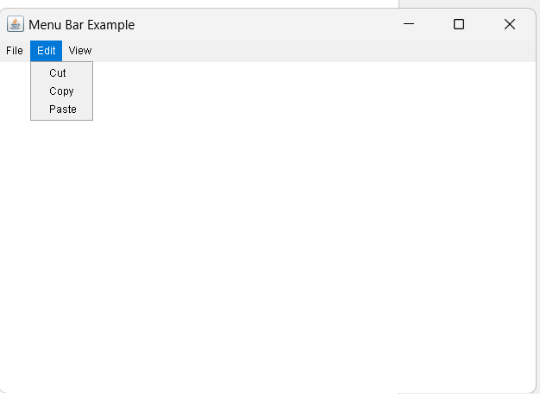

Practical no 6:
import javax.swing.*;
import java.awt.*;

public class IndianStatesFrame extends JFrame {
private JComboBox<String> statesComboBox;

public IndianStatesFrame() {
setTitle("Select Indian State");
setSize(300, 200);
setDefaultCloseOperation(JFrame.EXIT_ON_CLOSE);

// Create a panel to hold the combo box
JPanel panel = new JPanel();
panel.setLayout(new FlowLayout());

// Create the combo box and add items to it
statesComboBox = new JComboBox<>();
statesComboBox.addItem("Andhra Pradesh");
statesComboBox.addItem("Goa");
statesComboBox.addItem("Gujarat");
statesComboBox.addItem("Kerala");
statesComboBox.addItem("Maharashtra");
statesComboBox.addItem("Tamil Nadu");
statesComboBox.addItem("Uttar Pradesh");
panel.add(statesComboBox);
add(panel);
setVisible(true);
}

public static void main(String[] args) {
new IndianStatesFrame();
}
}
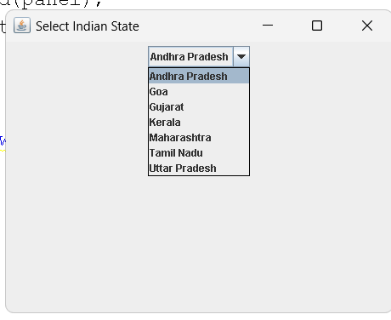
2.
import javax.swing.*;
import java.awt.*;

public class ScrollPaneDemo extends JFrame {
public ScrollPaneDemo() {
setTitle("JScrollPane Demo");
setSize(300, 200);
setDefaultCloseOperation(JFrame.EXIT_ON_CLOSE);

// Create a JTextArea with some text
JTextArea textArea = new JTextArea("This is a JTextArea with a JScrollPane.");

// Create a JScrollPane and add the JTextArea to it
JScrollPane scrollPane = new JScrollPane(textArea);

// Add the JScrollPane to the JFrame
getContentPane().add(scrollPane, BorderLayout.CENTER);
}

public static void main(String[] args) {
ScrollPaneDemo demo = new ScrollPaneDemo();
demo.setVisible(true);
}
}
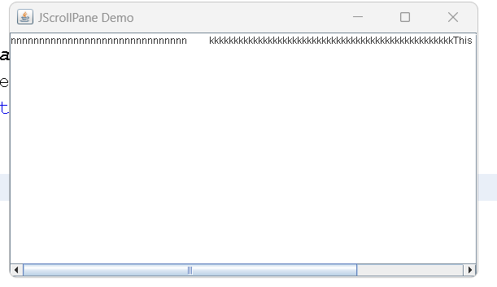

Practical no:7
import javax.swing.JFrame;
import javax.swing.JTree;
import javax.swing.tree.DefaultMutableTreeNode;
public class LanguageTree extends JFrame {
private JTree tree;
public LanguageTree() {
DefaultMutableTreeNode root = new DefaultMutableTreeNode("Languages");
DefaultMutableTreeNode frontEnd = new DefaultMutableTreeNode("Front-End Language");
DefaultMutableTreeNode backEnd = new DefaultMutableTreeNode("Back-End Language");
root.add(frontEnd);
root.add(backEnd);
DefaultMutableTreeNode html = new DefaultMutableTreeNode("HTML");
DefaultMutableTreeNode css = new DefaultMutableTreeNode("CSS");
DefaultMutableTreeNode javascript = new DefaultMutableTreeNode("JavaScript");
DefaultMutableTreeNode java = new DefaultMutableTreeNode("Java");
DefaultMutableTreeNode python = new DefaultMutableTreeNode("Python");
frontEnd.add(html);
frontEnd.add(css);
frontEnd.add(javascript);
backEnd.add(java);
backEnd.add(python);
tree = new JTree(root);
add(tree);
setTitle("Language Tree");
setSize(300, 300);
setDefaultCloseOperation(JFrame.EXIT_ON_CLOSE);
setLocationRelativeTo(null);
setVisible(true);
}

public static void main(String[] args) {
new LanguageTree();
}
}

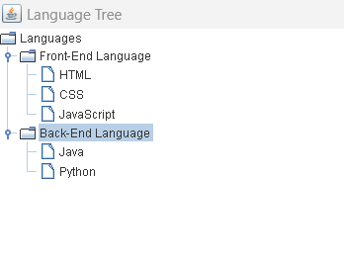

2
import javax.swing.JFrame;
import javax.swing.JTree;
import javax.swing.tree.DefaultMutableTreeNode;

public class JTreeDemo2 extends JFrame {
private JTree tree;

public JTreeDemo2() {

DefaultMutableTreeNode root = new DefaultMutableTreeNode("This PC");

DefaultMutableTreeNode f = new DefaultMutableTreeNode("Windows :C");
DefaultMutableTreeNode n= new DefaultMutableTreeNode("New Volume :D");
root.add(f);
root.add(n);
DefaultMutableTreeNode a = new DefaultMutableTreeNode("eclipse");
DefaultMutableTreeNode b = new DefaultMutableTreeNode("Intel");
DefaultMutableTreeNode c = new DefaultMutableTreeNode("oneschool-master");
DefaultMutableTreeNode d = new DefaultMutableTreeNode("PerfLogs");
DefaultMutableTreeNode e = new DefaultMutableTreeNode("Program File");
f.add(a);
f.add(b);
f.add(c);
n.add(d);
n.add(e);
tree = new JTree(root);
add(tree);
setTitle("Language Tree");
setSize(300, 300);
setDefaultCloseOperation(JFrame.EXIT_ON_CLOSE);
setLocationRelativeTo(null);
setVisible(true);
}

public static void main(String[] args) {
new JTreeDemo2();
}
}
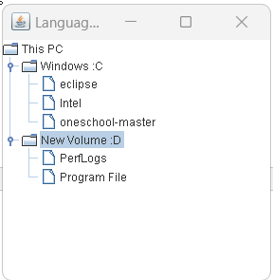

Practical no 8:

JTable:-
import javax.swing.JFrame;
import javax.swing.JScrollPane;
import javax.swing.JTable;

public class SimpleJTableProgram extends JFrame {
public SimpleJTableProgram() {
setTitle("Simple JTable Program");
setDefaultCloseOperation(EXIT_ON_CLOSE);
setSize(300, 200);

String[] columnNames = {"Name", "Age", "Gender"};
Object[][] data = {
{"Deepak", 25, "Male"},
{"Tanishka", 30, "Female"},
{"Pratik", 20, "Male"},
{"Sanika", 35, "Female"}
};

JTable table = new JTable(data, columnNames);
JScrollPane scrollPane = new JScrollPane(table);
add(scrollPane);

setVisible(true);
}

public static void main(String[] args) {
new SimpleJTableProgram();
}
}
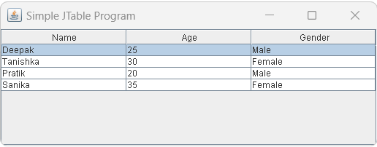

Practical no 9:
import javax.swing.*;
public class ProgressBarExample extends JFrame{
JProgressBar jb;
int i=0,num=0;
ProgressBarExample(){
jb=new JProgressBar(0,2000);
jb.setBounds(40,40,160,30);
jb.setValue(0);
jb.setStringPainted(true);
add(jb);
setSize(250,150);
setLayout(null);
}
public void iterate(){
while(i<=2000){
jb.setValue(i);
i=i+20;
try{Thread.sleep(150);}catch(Exception e){}
}
}
public static void main(String[] args) {
ProgressBarExample m=new ProgressBarExample();
m.setVisible(true);
m.iterate();
}
}

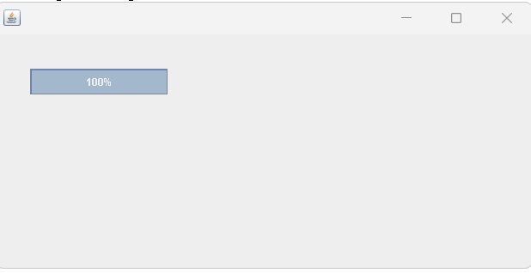

2.

import javax.swing.*;
import java.awt.*;

public class JProgresBarDemo
{
JProgressBar Obj;
int i=0;

JProgresBarDemo()
{
JFrame JFrameMain = new JFrame();

JFrameMain.setVisible(true);
JFrameMain.setSize(400,400);
JFrameMain.setLayout(new FlowLayout());

Obj = new JProgressBar(0,2000);
Obj.setValue(0);
Obj.setStringPainted(true);

JFrameMain.add(Obj);
}

public static void main(String[] args)
{
JProgresBarDemo jpd = new JProgresBarDemo();
jpd.iterate();
}

public void iterate()
{
while(i<=2000){
Obj.setValue(i);
i =i+20;
try
{
Thread.sleep(150);
}
catch(Exception e)
{

}
}
}

}
Op:
